**WEB DESIGN**

**PROJECT REPORT**

|  |  |
| --- | --- |
| **PROJECT TEAM** | |
| **Student No.** | **Student Names** |
| **x16134613** | **Nassima Kara** |
|  | **Benjamin Adeline** |
|  | **Lorenzo Cipriani** |

**\*\* Sales Web Site Latte e Biscotti \*\***

**\*\* Insert Project URL Here \*\***

**Section 1: Design**

* PROJECT PROPOSAL

## Project Overview

Latte e Biscotti is a growing italian company mainly specialised in the production and sales of clothes and shoes suitable for babies and children until the age of 12. The brand does not have any online presence except the company accounts in some social network such as Facebook, Instagram and Twitter. To face the needs of the customers and challenges of a growing demand, the owner of the company wishes to create a sales website where the customers and retailers can experience the Latte e Biscotti brand online across Europe and the United States.

The owner outlined some specific goals for this website:

* Introduce all the Latte e Biscotti products online to the customers and retailers;
* Increase the upselling and cross-selling by structuring the online offering;
* Attract new customers and grow the existing client’s base through their online presence;
* Automate and simplify the sales process to reduce the costs/time to complete a sale and improve the customers’ satisfaction.

To respond to the basic requirements, the preliminary plan consists in building an interface that will help the customers and retailers:

* To know more about Latte e Biscotti and its expertise.
* To view the collections and other offerings in their dedicated web pages;
* To make an order and payment, view and review their order history;
* To contact Latte e Biscotti;
* To have an overview of the Terms and Conditions, Shipping and Delivery policies, FAQ;
* To follow the company Latte e Biscotti on the social networks such as Facebook, Instagram and Twitter.

## Research / Investigation

In the preliminary phase of our research, we carried out our research through the websites of the biggest brands in the childcare segment:

* Jacadi: http://www.jacadi.com/en
* Petit Bateau: http://www.jacadi.com/en
* Tartine et Chocolat: http://www.tartine-et-chocolat.fr/fr-fr/

We established some researches according to the criteria that can be considered as important from a customer experience perspective. Overall, the three sites are using a hoverable dropdown menu in the navigation bar to ease the exploration of the catalog by the customer. An efficient search form is available at the top of the Petit Bateau and Tartine au Chocolat websites as it can help to go directly to a product associated with the different variants offered by the brand. However, Jacadi and Petit Bateau are not using any written efficiently to enhance the home page while the Tartine au Chocolat website finds an excellent balance between the graphic design and the descriptive content. The bottom of the websites are generally used to reference information about terms and conditions, delivery which is poor in the Jacadi home page. Eventually, the accessibility and privacy are part of the home page in the Petit Bateau and Tartine au Chocolat, the customers have the possibility to visit the website through their own account. The table below summarize the results of our researches across these three websites:

|  |  |  |  |
| --- | --- | --- | --- |
| Benchmarking criteria | Jacadi | Petit Bateau | Tartine et Chocolat |
| Overall Quality | Average | Good | Excellent |
| Navigation menu | Good | Excellent | Excellent |
| Search | Average | Excellent | Excellent |
| Usability | Average | Average | Excellent |
| Written Content | Average | Weak | Excellent |
| Bottom of the website | Average | Good | Excellent |
| Accessibility | Average | Average | Excellent |
| Privacy | Poor | Good | Excellent |

During our research, the Mothercare website has been integrated in our scope. Because of the growth, it is difficult to navigate through some websites as they contain too much information, options or photos. The excess of automation can be an explanation of this trend. Following our first meeting, we understand that the customer is still developing their positioning in the marketplace, therefore the purpose of the website is to develop an online marketing strategy with the customers and retailers. The approach that will be adopted is centered on a customer-centric interface focused on the presentation of the collections and the communication with the company. The purpose is also to associate the quality of the products with the identity of the brand through the customer experience.

## Requirements & Technical Approach

Once the business requirements have been analysed, the team approached the project from a technical perspective by using the UML case diagram to define the scope of the system, the list of system functionalities and the interactions between the system and the possible actors in the system. The system of the sales web site requested by Latte e Biscotti is defined by the following case diagram:

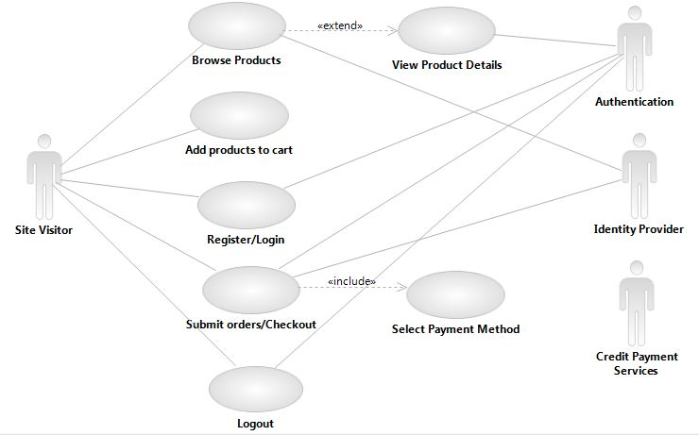

The main actor is the visitor (customer or retailer). The other actors are proceeding to the authentication during the creation of an account, the login/logout. The credit payment services is used during the last step of the sales transaction.

Based on the diagram, we can identify the main group of activities:

1. The visitor browses the products online and review the details of the products (type, age, season)
2. The visitor adds the products to the cart
3. The visitor is registering his account if he is a new customer. If the visitor is a retailer, this step would happen as soon as he is entering in the retail area.
4. The visitor is logging in his accounts if he is already a customer or retailer
5. The visitor is checking out
6. The visitor is logging out

After a review of the UML diagram, the team worked on the elaboration of few examples of UML classes. We agreed on the first mock-up and sitemap that should be presented to the company owner. The initial plan is to develop three versions of the web pages respectively for a web browser, an iPhone and a tablet.

## WIREFRAME / SITEMAP

As a result of the preliminary plan, the wiframe and sitemap of the website have been aligned to the objectives of Latte e Biscotti established in the previous section as follows:

|  |  |
| --- | --- |
| Web page | Preliminary structure of the website |
| Home page | The home page is the landing page where the visitors will be able to access to the information about the company, the products and search for a store across Europe and the United States. The visitors will have the possibility to access their dedicated space through two options: Customers or Retailers |
| About Us | This page presents the story of the company Latte e Biscotti since its creation and advertise the benefits of buying the Latte e Biscotti products (Know-How, quality of the fabrics, expertise) |
| The Collections main page for customers | The web page is offering the customers or retailers to access the following pages:   * About Us * The Collections * Sales * Find a Store   The customer will have the possibility to browse the collection or sales by three categories (Age, Type and Season) or Make A Gift.  The customer has the possibility to make an order through a specific form, view his orders and review his order history. |
| The Collections main page for the retailers | The web page is offering the customers or retailers to access the following pages:   * The Collections * Sales * Make an Order * Contact us (Form, Email or Phone)   The retailer will have the possibility to browse the collection or sales by three categories (Age, Type and Season).  The retailer has the possibility to make an order through a specific form, view his orders and review his order history. |
| Find a store | This page will help the visitor to locate a store across Europe and the United States |
| Sign in Sign out/Register page | This page will help to identify the type of visitor and redirect them to their dedicated space where they can login or register |

“The Collections” web page presents the products by season for the following segments of customers:

* Babies (0 – 6 months);
* Toddlers (6months – 36 months);
* Children (Above 36 months to 12 years);
* The shoes;
* The Home Collection of the Latte e Biscotti brand

While viewing the products, the customers and retailers will have the possibility to order online.

The main web page “The Collections” is also offering the option to “Make a gift” through online vouchers in the customer area only.

The footer in each web page will contain a link to the web pages related to the following topics:

* Terms and Conditions;
* Shipping and Delivery;
* FAQ (Frequently Asked Questions);
* Legal notice.

A loyalty space will be created to offer the option of joining the “Latte e Biscotti” in Facebook, Twitter and Instagram.

The following sitemap and wiframe are the result of the researches and requirements from the customer. The navigation tree is structured according the hierarchy listed in the following sitemap :

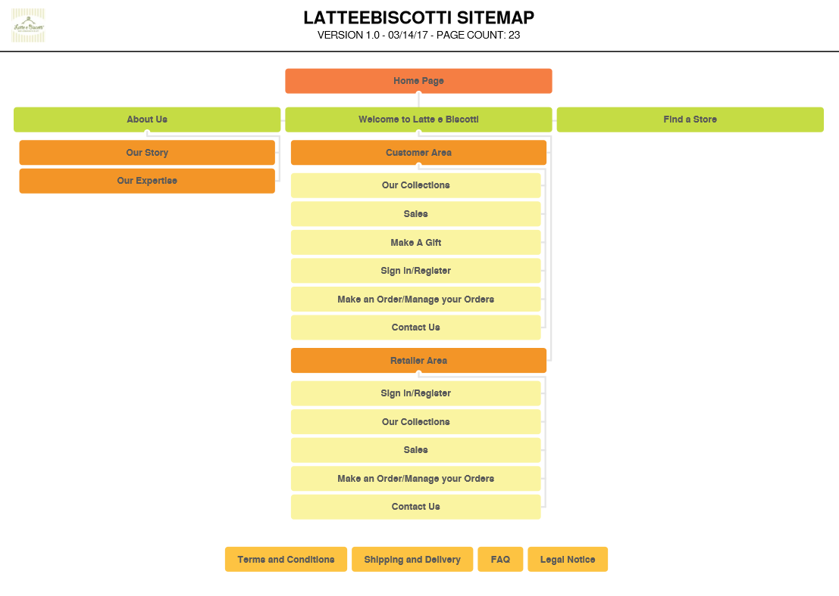

Here at the main pages of the wiframe (ref the file attached to the interim project file). Some changes might occur once the website will be developed

* Welcome web page

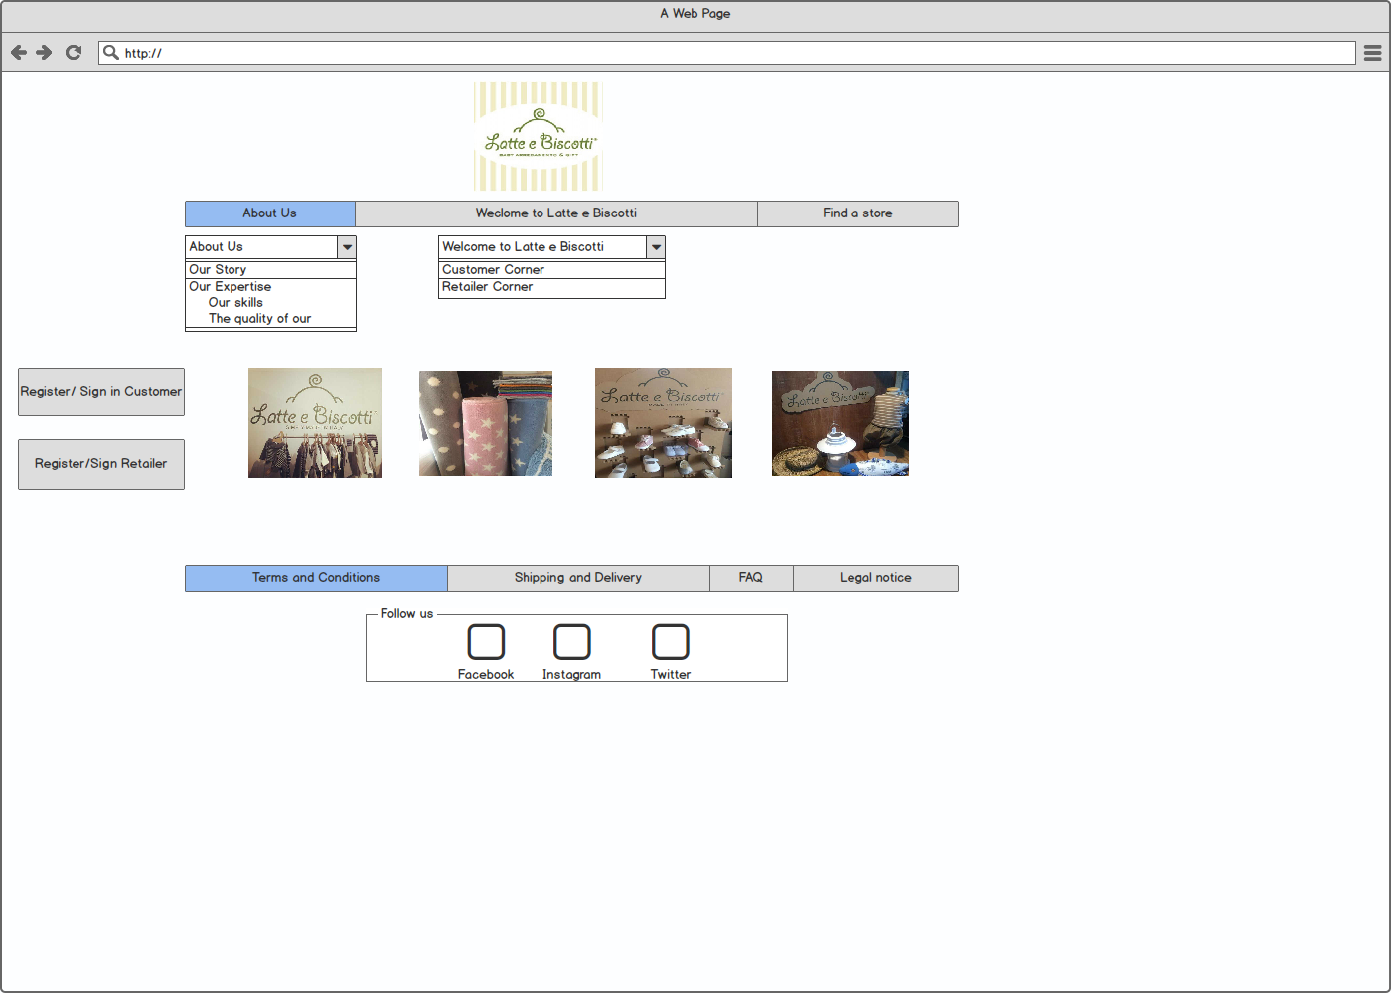

* Welcome web page

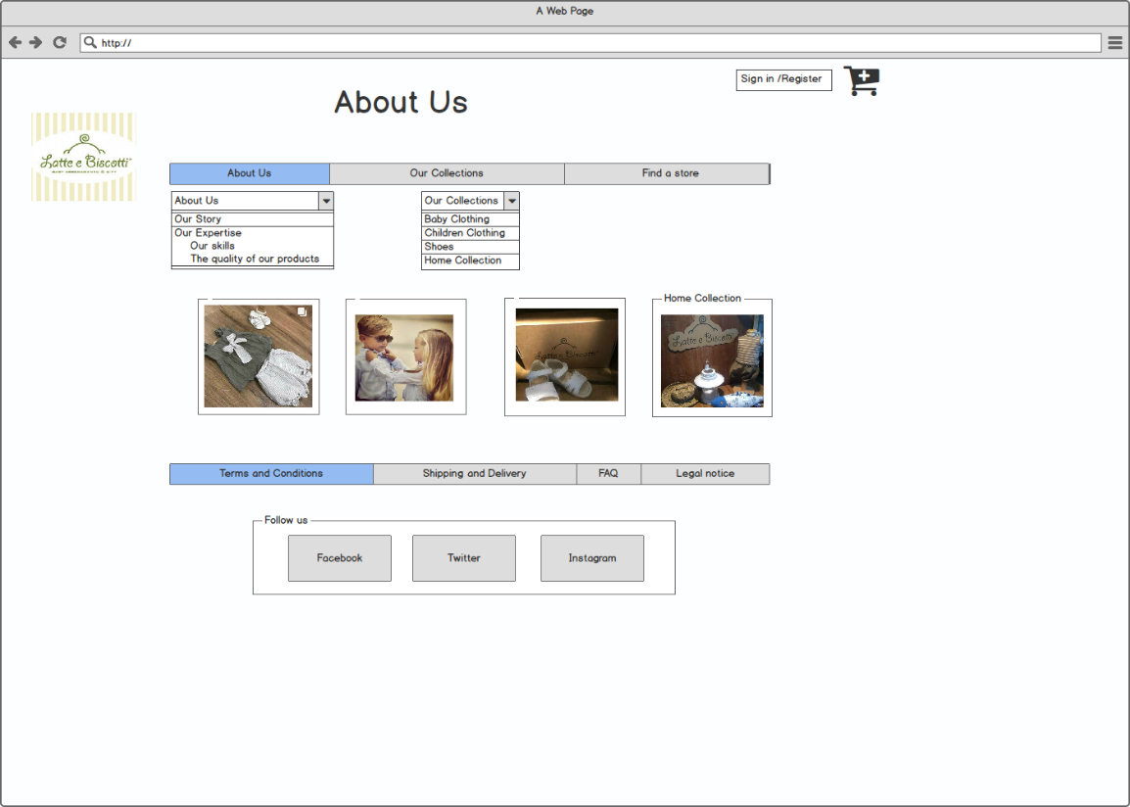

* End-user Our Collections web page

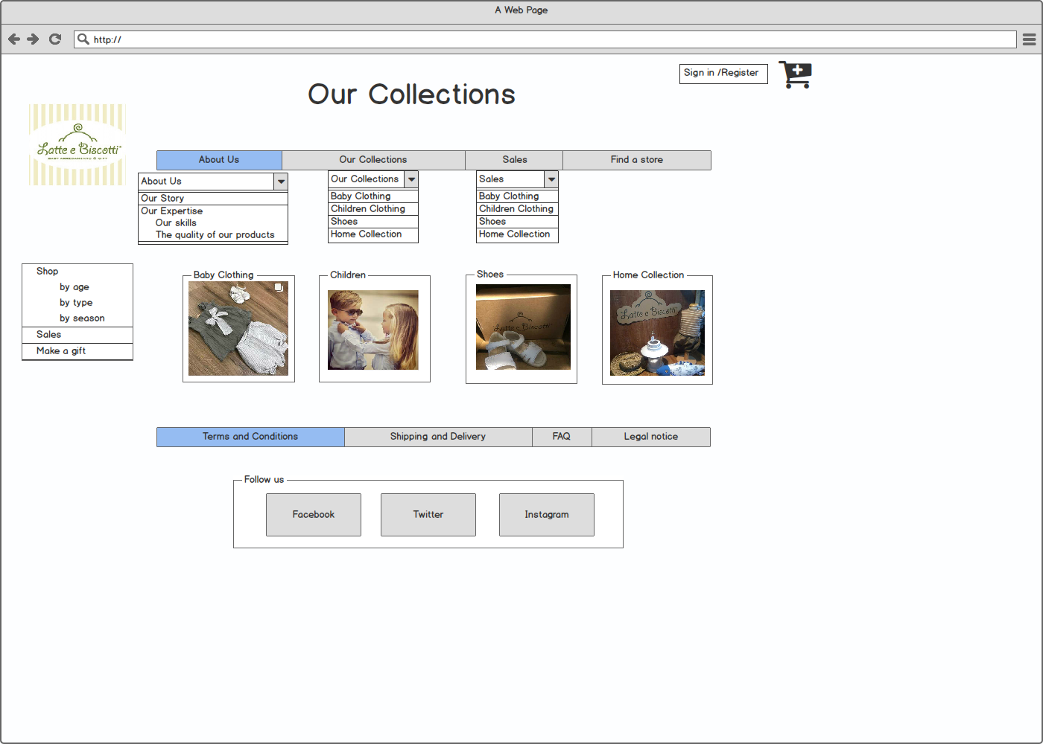

* Retailers Our Collections web page

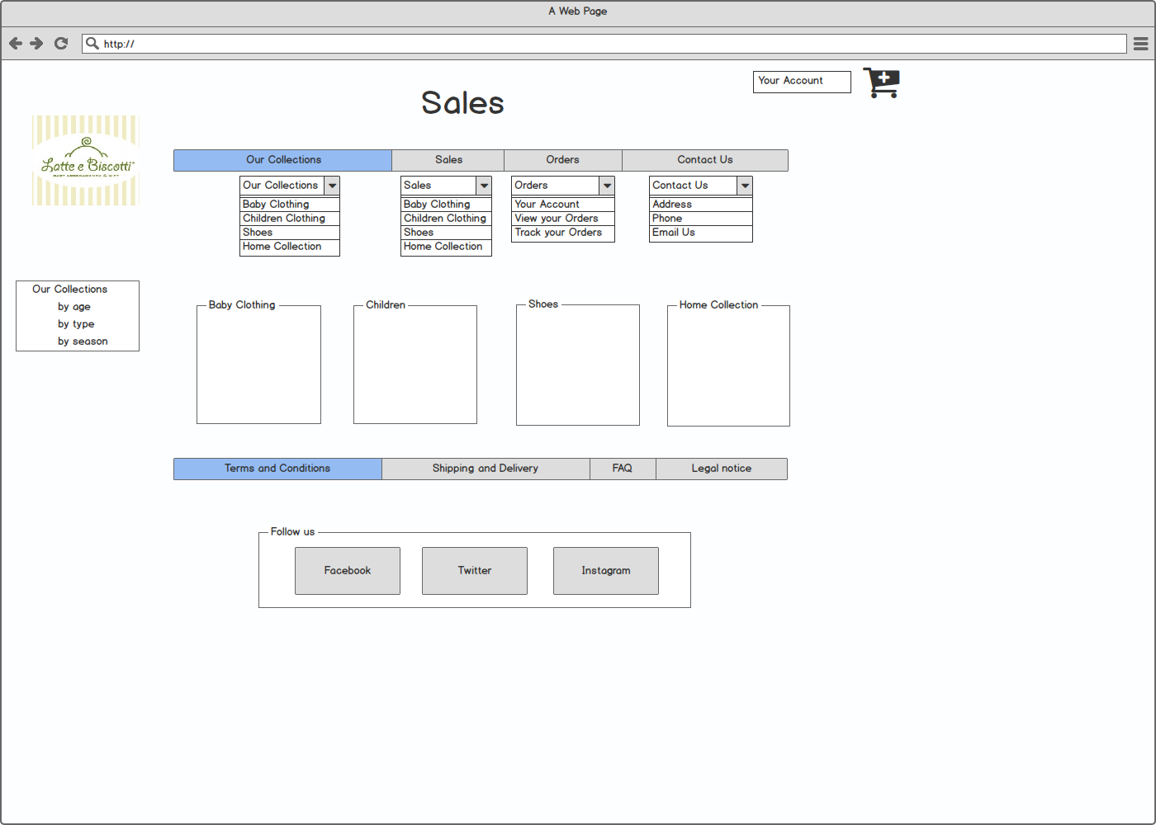

* Find a store web page

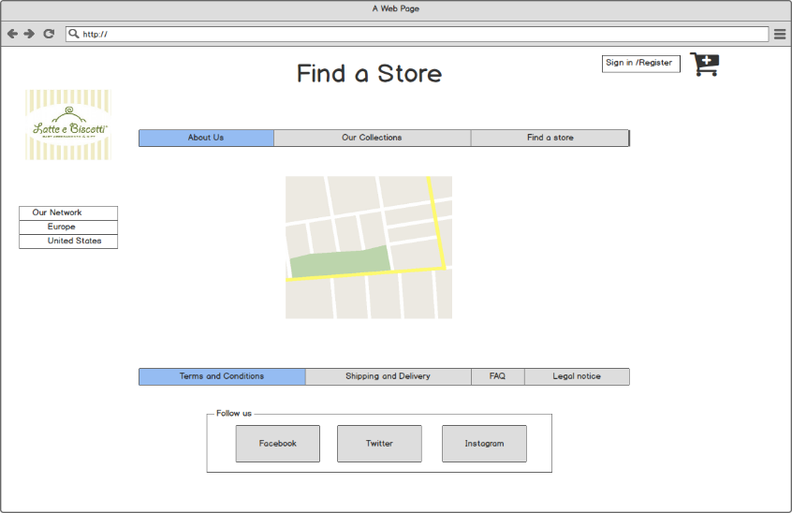

* Terms and Conditions web page

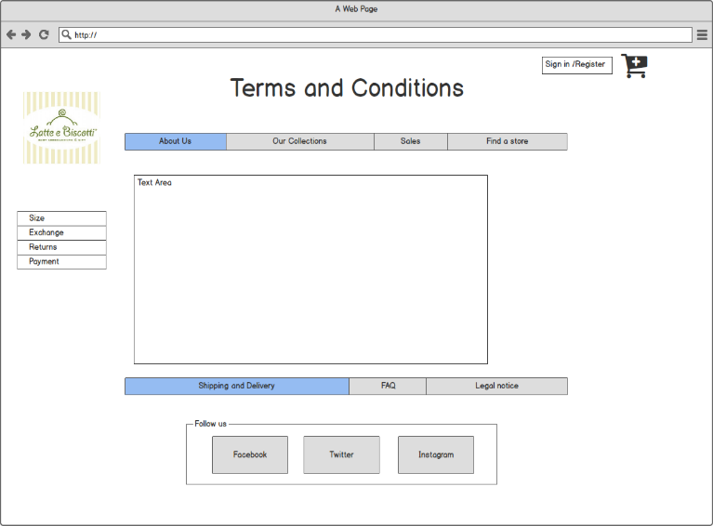

* Shipping and delivery web page

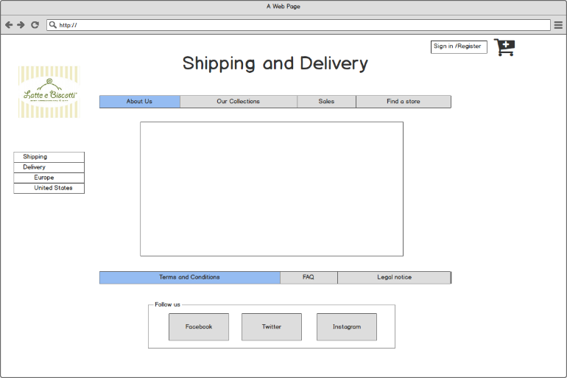

* End-user web page

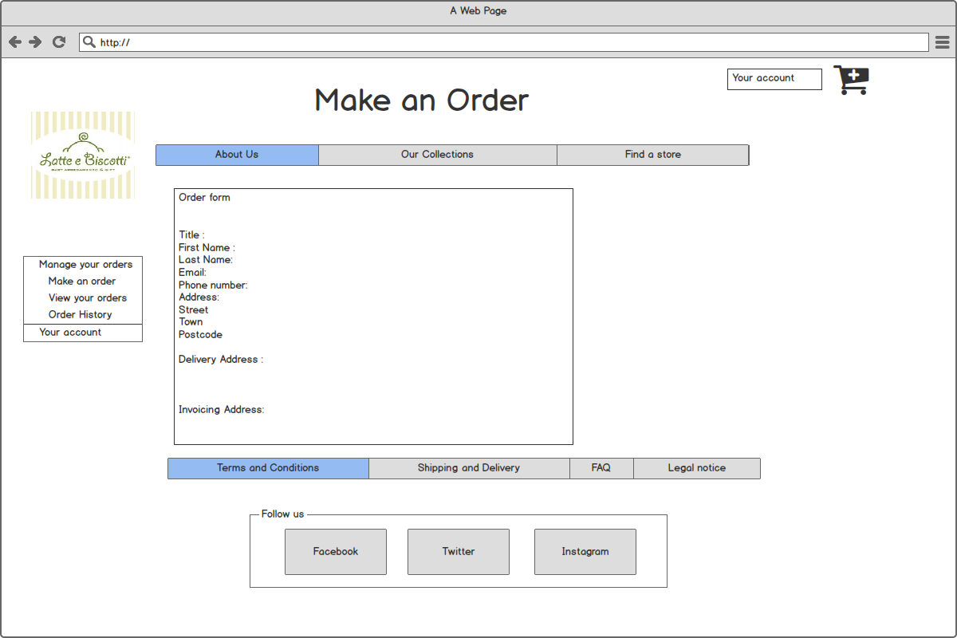

* Retailer web page

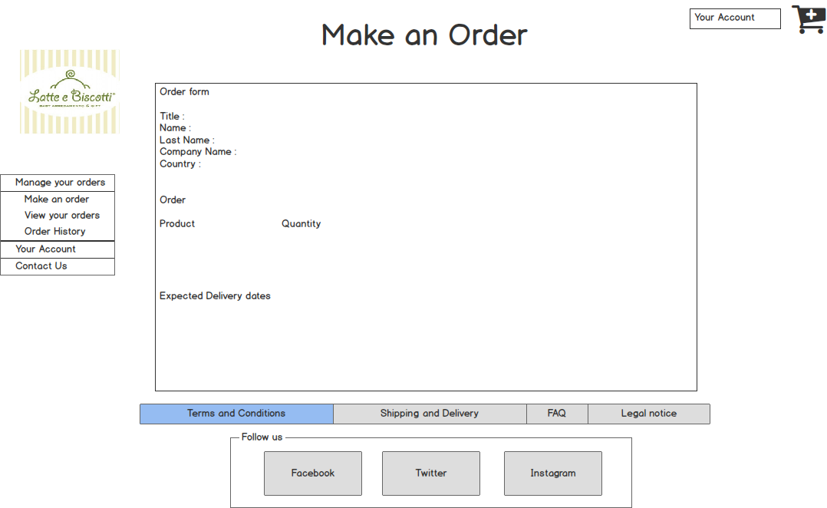

**\*\*\* The following sections should NOT be completed until you have FINISHED your website \*\*\*\*\*\***

**Section 2: Development**

* **PRODUCTION LOG**

** This section should outline how you went about developing your webpage, i.e. HTML, CSS, JavaScript. This should include information on requirements implementation, code development and technical details, such as errors or development issues and how you fixed these.

**Please note:** Make sure to include explanation (**as well as** comments in the HTML files) of any & all code that was taken from the web, or you will **not** receive marks for this third party code. **

**Validation**

** This section should look at validation of the website, were you able to validate the website, were there any errors and if so, how did you go about fixing them. Please include a screenshot(s) of your validation report here **

**Deployment**

** This section should include information on your choice of deployment, as well as the sites URL and a screenshot of the live site **

* **PROJECT TEAM**

** How did the project team break up the tasks required?

Who did what tasks? Did everyone evenly participate?

Were there any team issues? Etc. **

**Please note:** You will each be asked to individually peer review your team mates privately via Moodle also

* **CONCLUSION**

** Having finished the project, looking back, how did the project go?

Did you achieve what you set out to do?

Are you happy with the results?

Is there anything you might change if you had more time? Etc. **\*\***

* **REFERENCES & APPENDIX**

** Make sure to include any third party resources / information / code used here.

Make sure to reference correctly as needed, i.e. Harvard Referencing, or marks will be deducted. **